Distraction Workbook

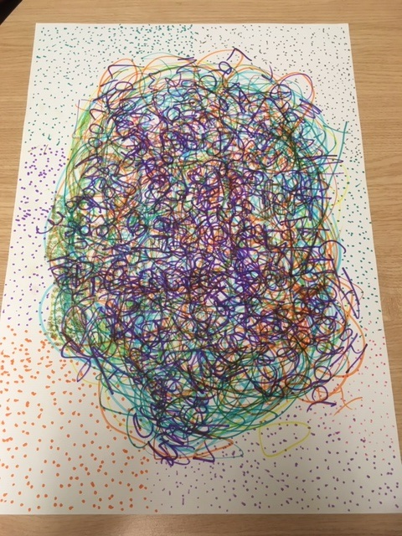


Registered Charity
Number 1186059

Introduction

Youth Connect South West is an independent non-profit charity supporting young people in Bath and North East Somerset and beyond. We provide both universal and targeted opportunities for young people aged 11- 25. We operate from various localities and have our own youth hub- Southside in Bath. We offer a range of support including youth work, 1-1 support and careers advice and guidance. We do this by:
​
- Keeping young people safe – working in the best interests of young people and putting them at the centre of everything we do
- Collaboration – working with families, communities and other stakeholders to make things better for young people.
- Meeting expectations – going “the extra mile” to support young people
- Inclusion - being there for those who need us
- Determination and creativity – modelling the importance of trying new things, continually learning and never giving up.

About the author
Steff Reynolds is an Engagement worker and current staff trustee. Her background is in community work (for both statutory and voluntary organisations) for over 25 years. She is a qualified youth worker and has had the great pleasure of supporting 100's of young people in BANES over the past 11 years. Her job is often a challenge, very rewarding and never boring.

About this resource
This workbook has been developed from a range of resources used and adapted over several years in consultation with young people. The workbooks are designed to lead the young person through the topic to gain knowledge, develop skills and the confidence to feel good about themselves and respect others. You can complete all the workbook or use sections. It is designed for individual support and completed through weekly sessions. All you need is the workbook, pens and felt tips and a safe space to meet up.
Practitioners should be aware that this resource may raise the need for support and advice from other specialist agencies and will help to provide useful referral information.

Let’s start with Breathing…
When we are anxious, scared or angry adrenalin starts to pump around the body putting us on alert. This is known as fight, flight or freeze. Its part of our natural defence. If we are regular feeling at risk, for whatever reason, it becomes a pressure in itself. Learning to breathe calmly is a great life skill that helps with anxiety including lack of confidence, interviews, driving tests and difficult situations. Taking slow deep breathes helps you to focus your mind and your next response.
You can do the exercise standing or sitting and for as long as you like. The more you practise the technique the easier it.

- Place your hand on your belly and breath deep so you feel your hand move as your belly extends
- Try breathing in through your nose and out through your mouth
- Count steadily from 1-5 to keep breathes equal
- Exhale slowly counting 1-5, focusing on the movement of your belly
- Try to do this for around 5 minutes

Another tip is to try adding the 54321 technique:

- What five things can you see?
- What 4 things can you feel?
- What 3 things can you hear?
- What 2 things can you smell?
- What can you taste?
Don’t worry if you can’t remember them all- you will remember something- and it will help you focus on what’s around you and your breathing.



Which brings us on to a little bit of Mindfulness….

Mindfulness is about understanding how you are feeling and what is happening around you at that moment in time.
You may feel happy, sad, guilty, angry, reflective or content.

Everything we feel is important. How we feel changes all the time. It’s ok to notice our emotions. Even if they concern us it’s good to know where we are, in the moment.

Stop for a minute:
- How am I feeling?_
- What can I see?
- Have I felt like this before?
- Who could help?
What I need to do next ….

You might decide you want to be with friends or family or you need to be on your own. Only you will know what you need ….

It is good to talk to someone to if you want help to unpick a problem. Often through talking we find our own solutions or get a really good piece of advice we can act on. After you talk to someone you trust you will feel lighter and more able to cope.

Reading is a great distraction, books, comics, even recipes…

You might want to work through your feelings more before you talk: you can try writing down how you feel in a diary or a letter to a friend (you can destroy them after if you like), or do a bit of research

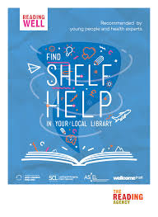
Find shelf help books in your local or school library
Reading Well for young people recommends expert endorsed books about mental health, providing 13 to 18 year olds with advice and information about issues like anxiety, stress and OCD, and difficult experiences like bullying and exams.
The books have all been recommended by young people and health professionals and are available to borrow for free from public libraries.

Doodling, drawing, painting, colouring- anything Arty can be really good for taking you away from your stresses and anxieties….and recent psychological research has found that doodling in class could actually benefit students' attention, memory, and learning- just keep it inoffensive.
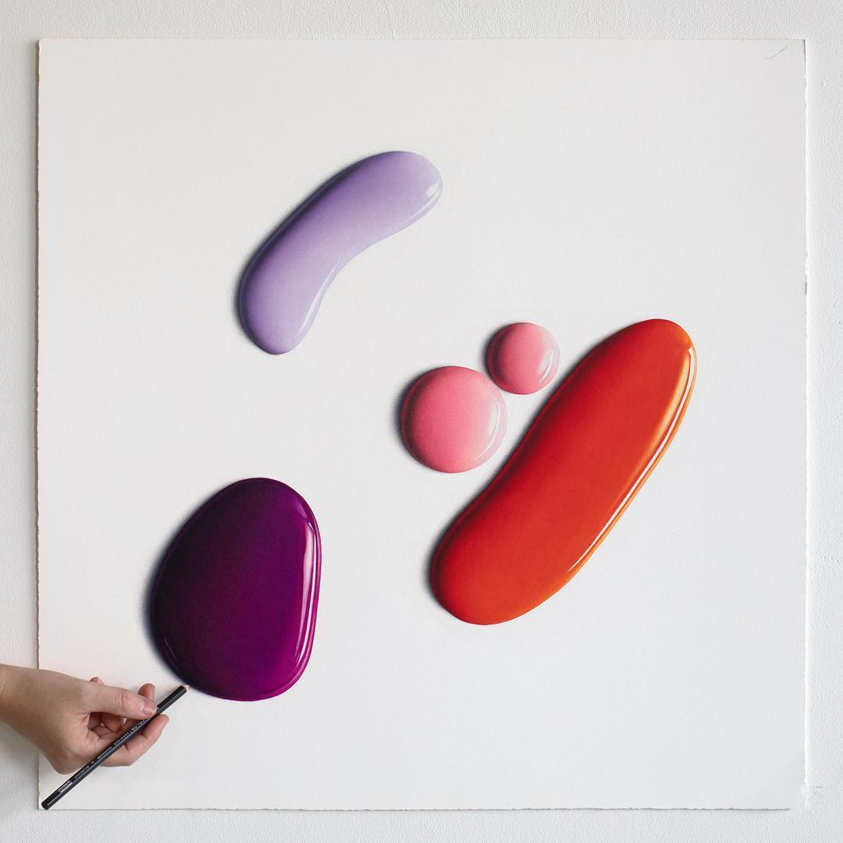

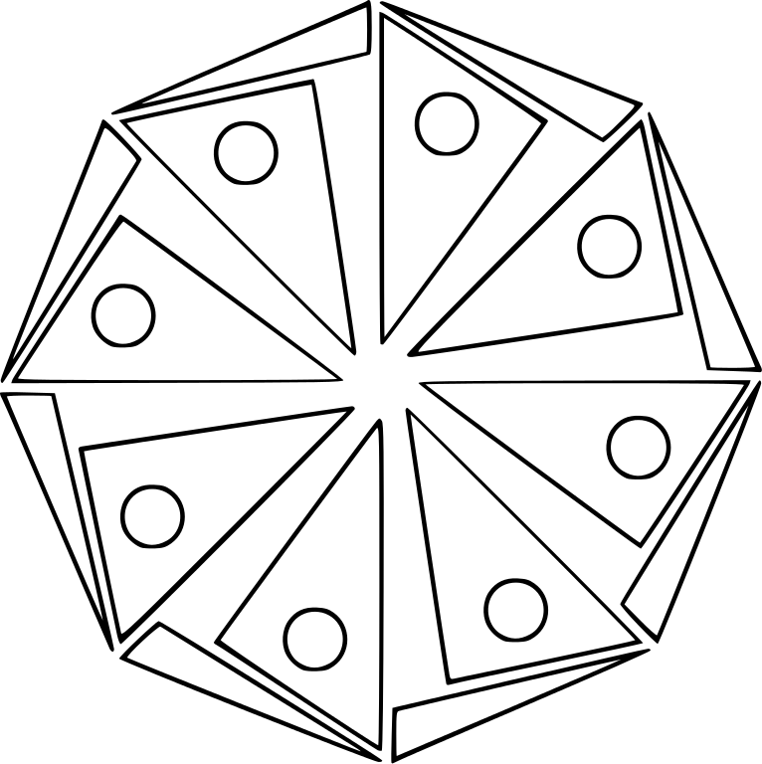

Colour me!!

and lead to another distraction…Cooking anyone?

Make you own Pizza
- Make the base: Put the flour into a large bowl, then stir in the yeast and salt. Make a well, pour in 200ml warm water and the olive oil and bring together with a wooden spoon until you have a soft, fairly wet dough. Turn onto a lightly floured surface and knead (great for getting rid of frustration!) for 5 mins until smooth. Cover with a tea towel. You can leave the dough to rise if you like, but it’s not essential for a thin crust.
- Make the sauce: Mix the passata, basil and crushed garlic together, then season to taste. Leave to stand at room temperature while you get on with shaping the base.
- Roll out the dough: If you’ve let the dough rise, give it a quick knead, then split into two balls. On a floured surface, roll out the dough into large rounds, about 25cm across, using a rolling pin. The dough needs to be very thin as it will rise in the oven. Lift the rounds onto two floured baking sheets.
- Top and bake: Heat oven to 240C/fan 220C /gas 8. Put another baking sheet or an upturned baking tray in the oven on the top shelf. Smooth sauce over bases with the back of a spoon. Scatter with cheese and tomatoes, drizzle with olive oil and season. Put one pizza, still on its baking sheet, on top of the preheated sheet or tray. Bake for 8-10 mins until crisp. Serve with a little more olive oil, and basil leaves if using. Repeat step for remaining pizza or freeze for another day.

the base
- 300g strong bread flour
- 1 tsp instant yeast (from a sachet or a tub)
- 1 tsp salt
- 1 tbsp olive oil, plus extra for drizzling

the tomato sauce
- 100ml passata (or drain a tin of tomatoes and mash them up with dash of ketchup!)
- handful fresh basil or 1 tsp dried mixed herbs
- 1 garlic clove, crushed
- Salt and pepper

the topping
- 125g ball mozzarella, sliced or other cheese
- handful grated or shaved parmesan (optional)
- cold meat, frozen veg, tuna, onion, pineapple – whatever you fancy
- top with fresh basil leaves
after food comes Exercise….

Get outside-run or walk  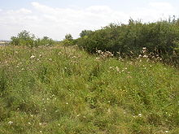 | Ball games alone or with others
Go for a swim  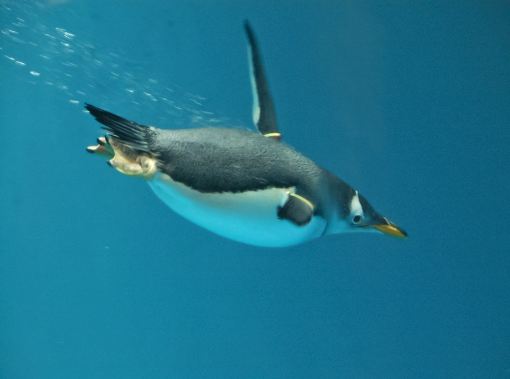 | Dance like you’re on your own  
Cycle to school, work or for fun  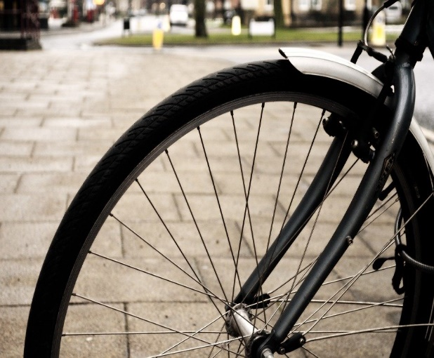 | Use tins instead of weights!  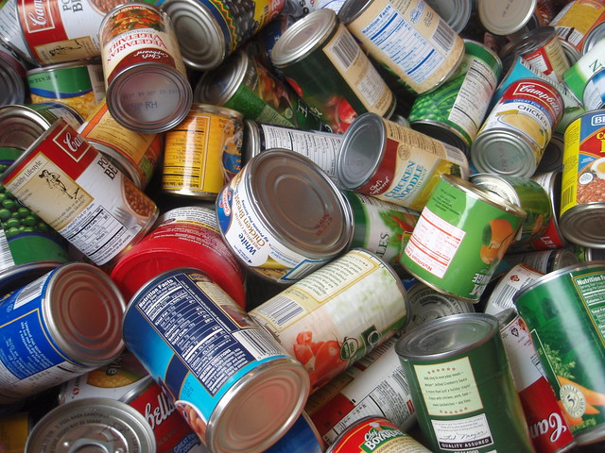
Work out on your own or with others. Inside or outdoors. it doesn’t matter….

Try working out to Music

Create a play list here of music that helps fit your mood…

- happy -
- sad -
- energised -
- connected -
- Calm -

What’s your Ultimate play list?

It doesn’t matter what kind of music you like, whether you like to listen or play an instrument, music makes us feel emotions and gives us energy and can even help our bodies to heal. Pretty groovy stuff.
If you listen to music it can help you focus on other stuff like….
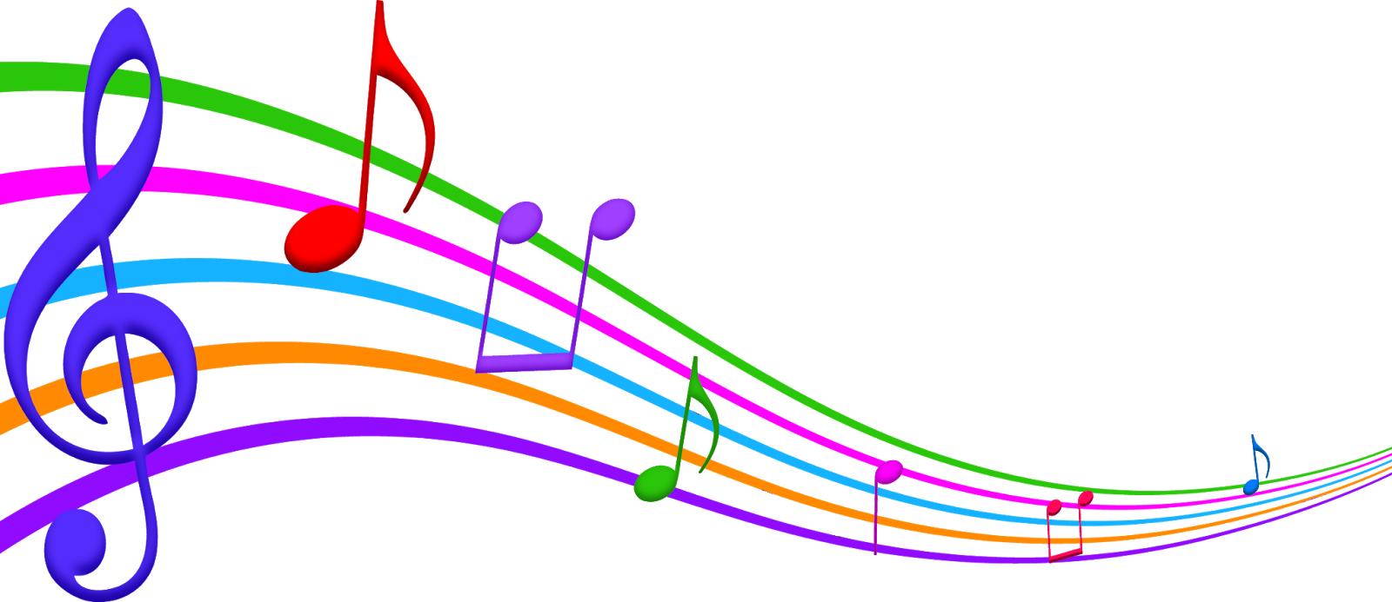

Trying out different Crafts
Make a stress ball  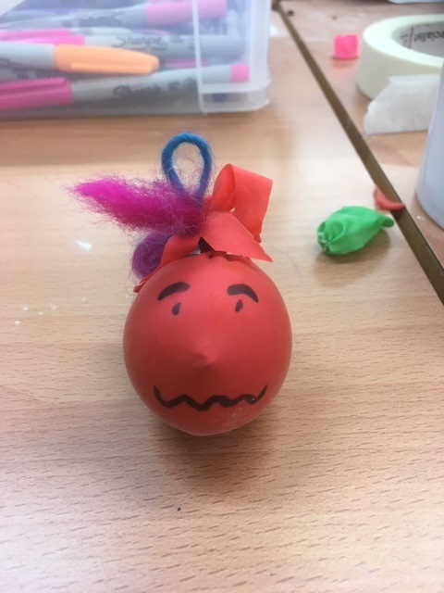 | Make and paint  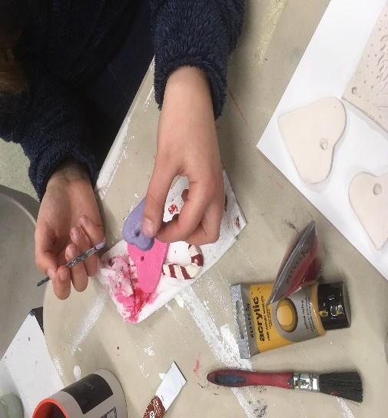
Make a dream catcher  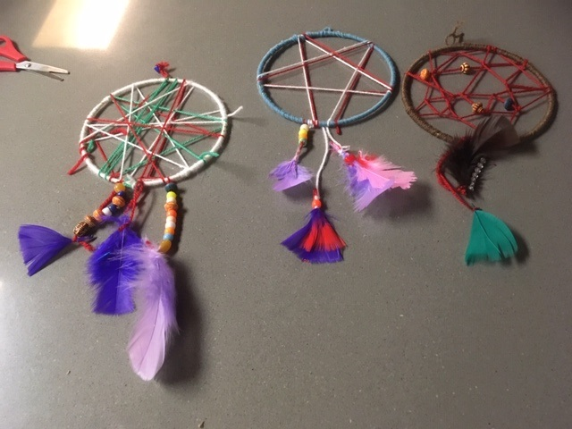 | Play with clay  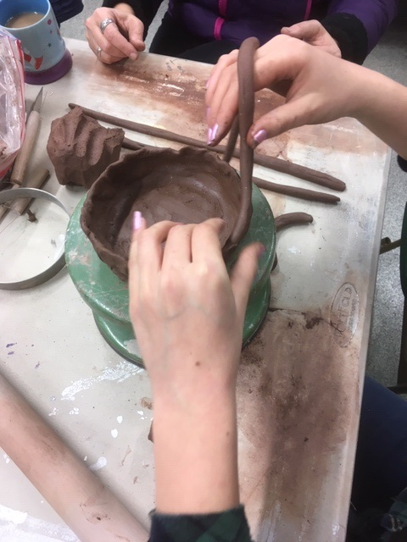
Make pom poms or knit  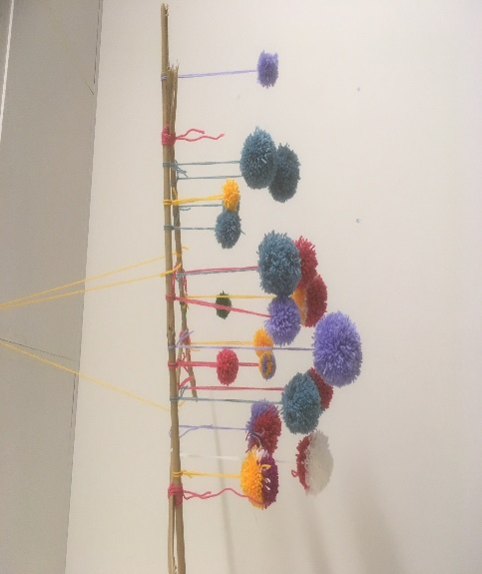 | Try a tie dye  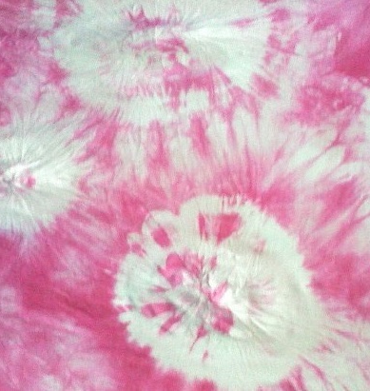
There are loads of things you can do and loads of online resources

….Online resources? How about Home beauty products?

Tomato and Cucumber Toner
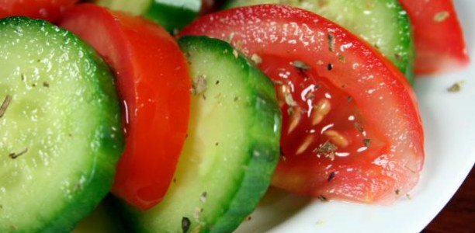
- One cucumber
- One large tomato

Method
Blend your (chopped) veggies in a food processor until smooth. Pat the mixture onto your face using a cotton pad or your fingers. Leave on for five minutes, and then rinse with warm water.
Note: For oily or acne-prone skin, use every day for the best results. Keeps in the fridge for 4 days

Sugary Minty Lip Scrub
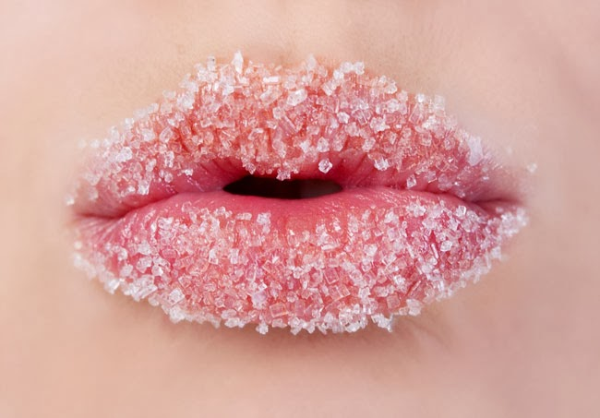
- ½ teaspoon of olive oil
- 1 teaspoon of caster sugar
- A drop or two of peppermint extract

Method
Mix these ingredients together and rub onto the lips, massaging for a few minutes.
Quick Zit Blaster:
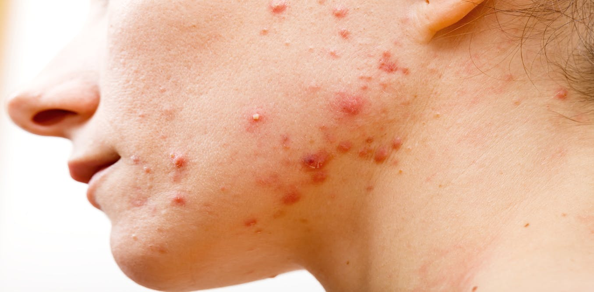
1 Tsp baking soda
Water to mix

Method
Mix 1 tsp. of baking soda and a few drops of water in the palm of your hand to make a paste. Apply to offending pimple. Massage on that spot for a minute. Let it sit on 5 minutes. Remove with water. Rinse with cotton ball and toner or witch hazel. Kills bacteria and neutralizes pH.

There are soooo many cheap and easy beauty treatments online for all types of skin and hair, for everyone.

Take time to pamper yourself and enjoy looking after you.

Nonverbal signs you are struggling can be really useful for people around you.
e.g. paint your nails a certain colour to let people know you are ok/ not ok without having to say a word. Genius eh?

Ok Not ok
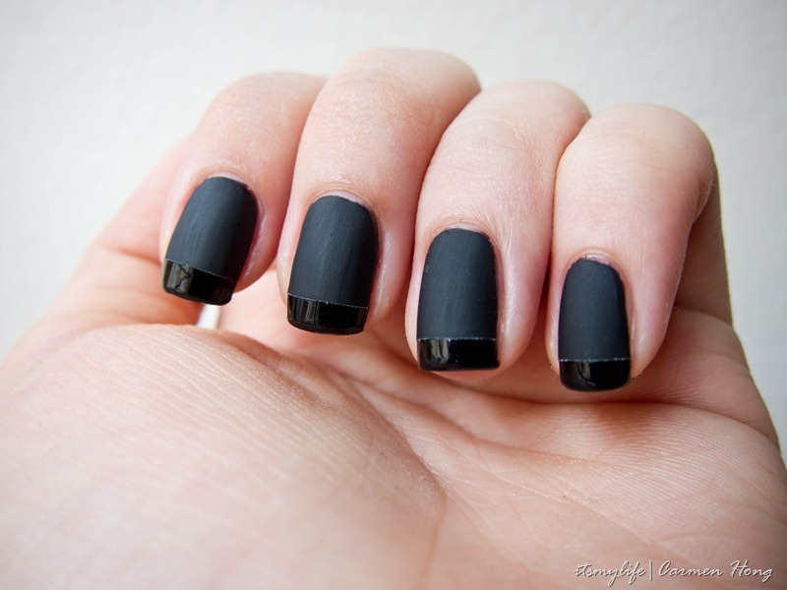
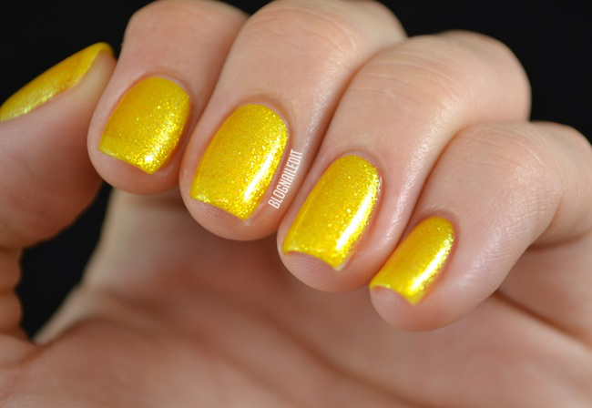

Clean & Declutter
Could you relax and unwind at a spa that was cluttered and disorganized? Probably not. The same is true for your home. Cleaning and organising your room will make your experience more enjoyable. Don’t forget to clean up the kitchen when you’ve finished the preparation, or your parents will be on your case…Set the mood…..Set the space…Get the music on
Don’t get stuck in a loop
We hear over and over again that stress and anxiety are unhealthy. And all that talk makes us, well, stressed. Here's how a little short-term anxiety can actually benefit your brain and body.
It can make you more resilient
Learning to deal with stressful situations can make future ones easier to manage.
It can increase immunity—in the short term
When the body responds to stress, it prepares itself for the possibility of injury or infection.
It helps boost brainpower
The body's response to stress can temporarily boost memory and learning scores.
It motivates you to succeed
Good stress may be just the thing you need to get job done. The key is viewing stressful situations as a challenge that you can meet, rather than an overwhelming, unpassable roadblock.

Here are the best and worst ways to de-stress right now.
Best | Worst
Get some fresh air | Drinking/ smoking/ drugs
Go and talk to someone | Isolating yourself
Switch off your social media/ phone | Ignoring the problem
Have a routine | Blaming others
Focus on your breathing | Dwelling on the negatives
Imagine yourself somewhere calm | Eating your feelings!
Be creative | Caffeine
My best way to destress: | My worst way to destress:

Taking back control

Whatever you are trying to change or improve in your life it’s important to remember that you can do it. Recognise your strengths and weaknesses. Understand when you do something well or overreact. We all do it.

By working through this programme, I hope that you have found some ideas to help you. Now’s the time to try them out on your own. Remember to be proud of yourself when things go well and to learn from the things that don’t.

A good way to remember strategies and techniques is to visualise a bucket: it is filling up and you must turn the taps on to stop it overflowing. You’ve got this. Each strategy will open a tap. Eg deep even breathing.

Write your own ideas by the taps….

