What keeps you afloat?
When we feel overwhelmed it can be helpful to look at what protective measures we already have in place so we can turn to them. Have a look at the example below and then have a go at filling one out yourself. Name the people, activities and support you can turn to in tough times
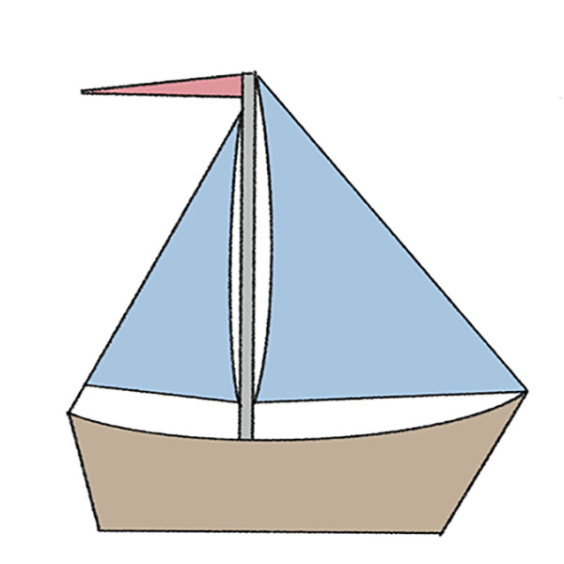
VOLUNTEERING
COPING MECHANISMS
DIET
HOPES AND DREAMS FOR THE FUTURE
ALONE TIME
HOBBIES
INDOOR

OUTDOOR

EXERCISE

PARTNER
FRIENDS
FAMILY
WORK
PETS
RELIGION
SPIRITUALITY

